**THERMO-ELECTROMECHANICAL MODULE**

1. Once ThermoElectroMechanical Analysis. Open the file pzr_sensor that we have already saved.
2. Follow the instructions.

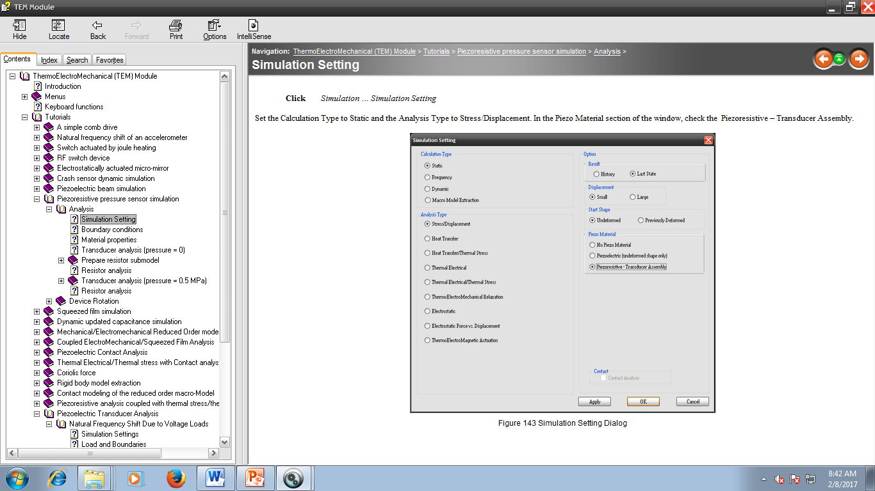

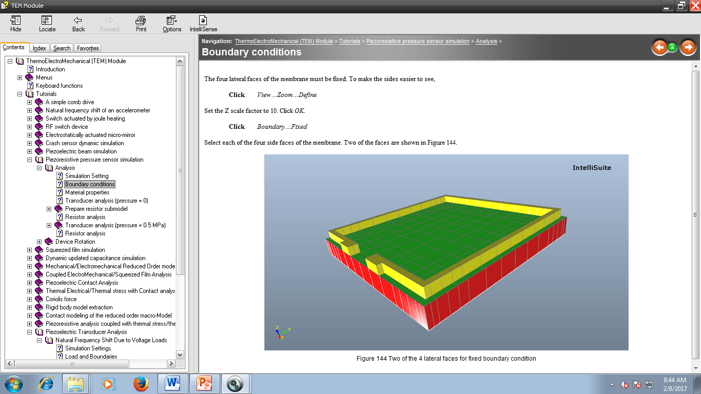

1. Click Material🡪 Check/ Modify

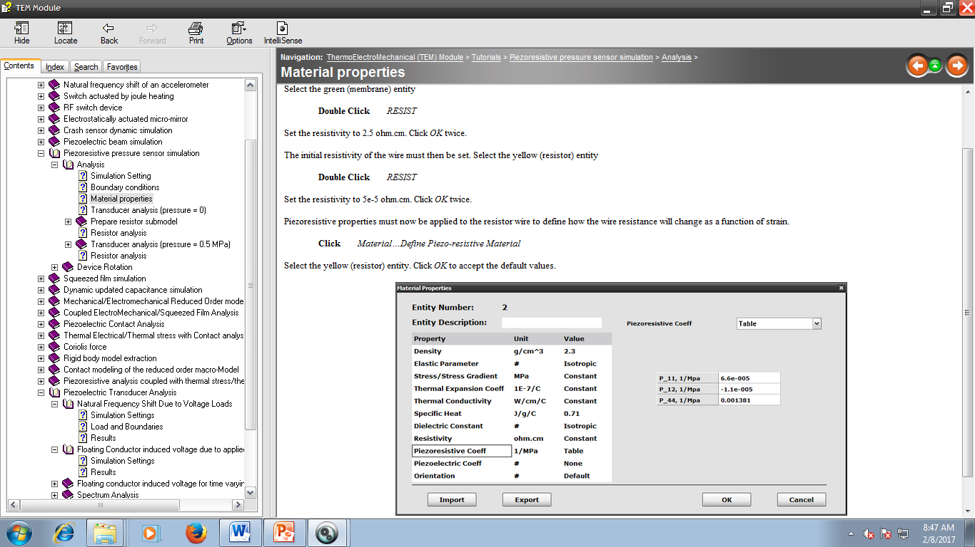

1. For the initial simulation, no pressure is applied. Now click Analysis 🡪Start Static Analysis. All results should be zero.

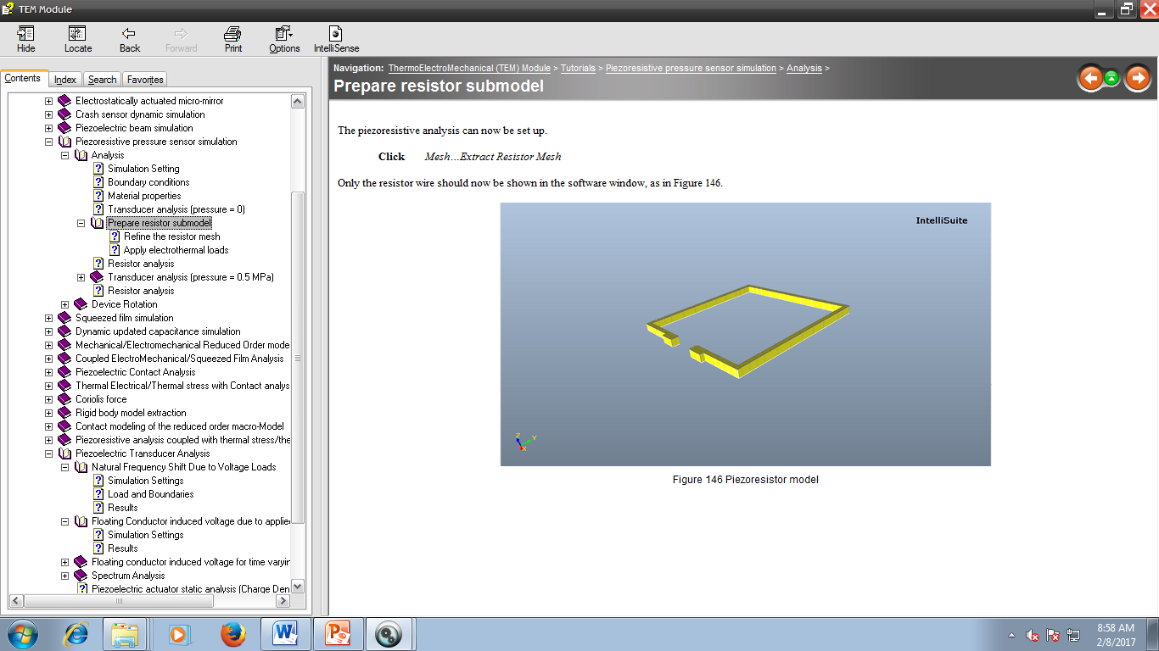

1. Click Mesh🡪 Auto. Enter a maximum mesh size of 5 micrometer.

